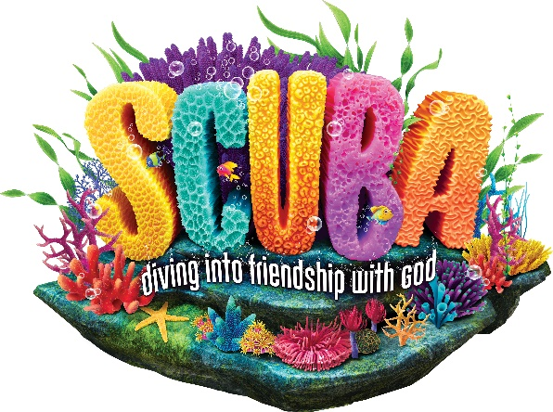
VACATION BIBLE SCHOOL
July 8 - 12
9:30 am – 12:00 pm
Friendship Church of the Brethren
217 Mansion Road, Linthicum, MD 21090
Preschool ages 3 & 4 and Kindergarten - 5th grade completed
Registration Fee - $15.00 per child
Take kids deep into an amazing undersea adventure where they’ll experience the ever-flowing, never-ending love of God. At Scuba VBS, kids will be immersed in the Word and discover what living water is really all about! A week of songs, crafts, games, snacks and exploring the Bible.
Information or Questions? Call Cheryl Burgoon: 410-789-1527
or email the church: friendshipcob@gmail.com
Website: www.friendshipbrethren.org

