2024 Vacation Bible School Registration Form
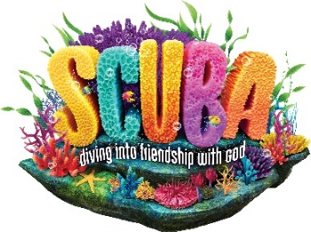
Friendship Church of the Brethren, 217 Mansion Road, Linthicum, MD 21090
July 8-12, 9:30 a.m. – 12:00 noon

Child’s Name: ______________________________________________

Birthdate: ___________________ Grade completing or completed this year (2023/2024) ________

Street Address: _________________________________________

City: _______________________ State: ____________ Zip code: ____________

Parent/ Guardian Name(s): ____________________________________________________________
Home Phone: ________________________ Parent Cell Phone: _________________________
Email: _____________________________________ Check box to be on our Email list:

Emergency Contact: ____________________________________
Relationship to Child: ____________________________ Phone: _____________________________

2nd Emergency Contact (If applicable): ____________________________________________
Relationship to Child: ____________________________ Phone: _____________________________

ALLERGIES/ Medical issues that may need attention: _______________________________________
___________________________________________________________________________________

Other Notes: ________________________________________________________________________
__________________________________________________________________________________

Name of home church if any: __________________________________________

If a child has a headache, fever, or any indication of illness please keep them home.

CLASS SIZE IS LIMITED. Please Pre-register early to help us plan class sizes!
Fees - $15 per child
Cash or Check. Make check payable to “Friendship Church of the Brethren”.
If paying with check write VBS in the memo.

Mail registration form to the church or give to Cheryl Burgoon or drop form off in church mail slot.

Questions? Call Cheryl Burgoon: 410-789-1527 or email the church: friendshipcob@gmail.com

